Syuria Amirrudin

1. Write an R program to create three vectors a, b, c with 5 integers. Combine the three vectors to become a 3×5 matrix where each column represents a vector. Print the content of the matrix. Plot a graph and label correctly.

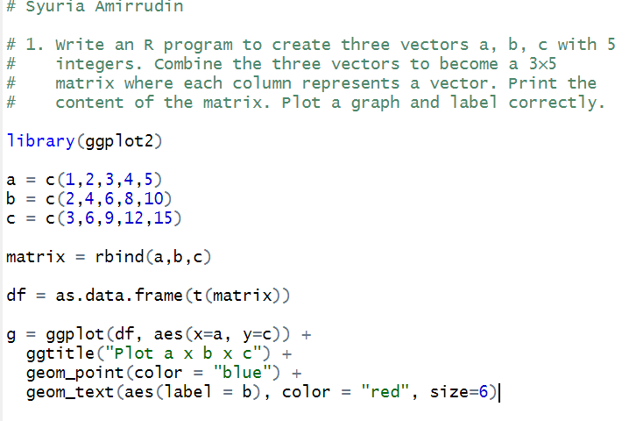

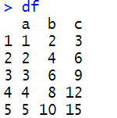

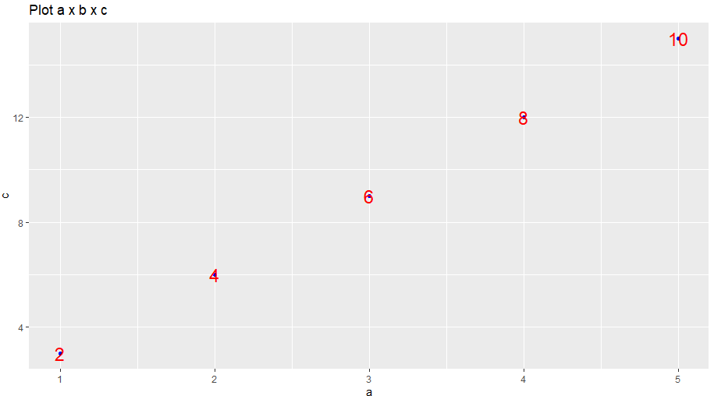

2. Write a R program to create a Data frames which contain details of 5 employees and display the details. (Name, Age, Gender, Role and Length of service).

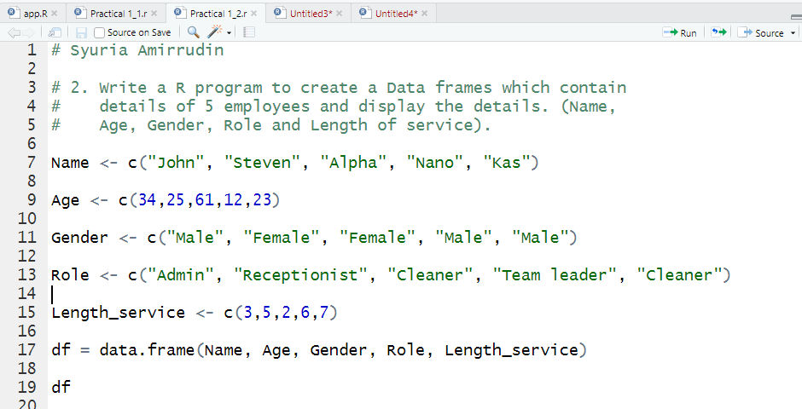

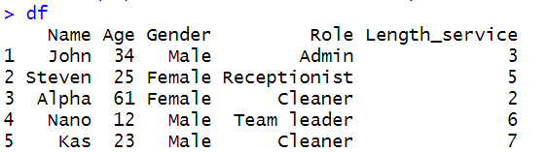

3. Import the GGPLOT 2 library and plot a graph using the qplot function. X axis is the sequence of 1:20 and the y axis is the x ^ 2. Label the graph appropriately. install.packages("ggplot2", dependencies = TRUE)

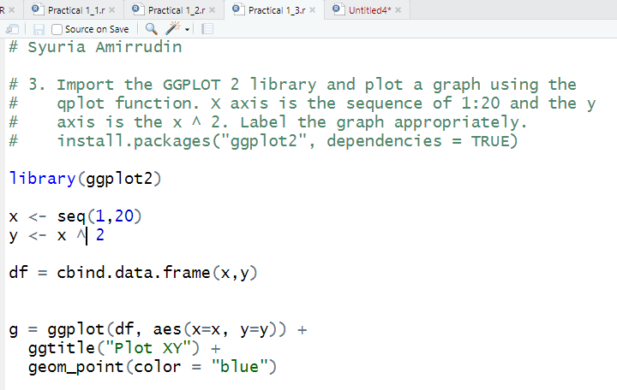

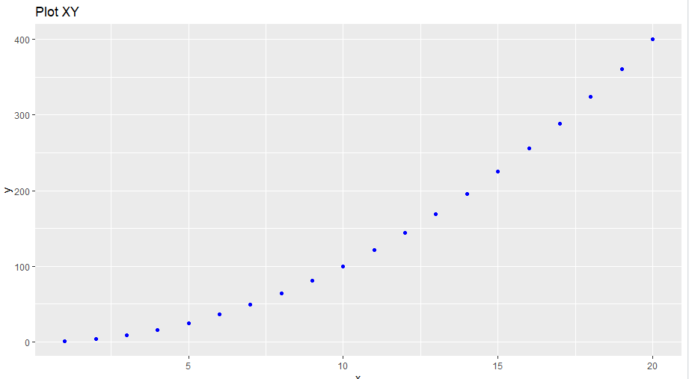

4. Create a simple bar plot of five subjects

